Bug Report For the Project:

demo.prestashop

 | General information
Customer | PrestaShop Live Demo
Created by (Author) | Yahia Cherrat - QA Tester
Preparation date | 2026-09-20
Version | 1.0
Status | Done

Revision History

Version | Description | Author | Date |  | Approved by
 |  |  |  | Author |  | Date
1.0 | Initial Phase 2 bug report pack | Yahia Cherrat - QA Tester | 2026-09-20

bug report:

ID | Summary
BR-001 | Home page loads extremely slowly

# | Steps to reproduce

- Open Google Chrome

2. | Open the PrestaShop demo
3. | Navigate to the home page
4. | Open Chrome DevTools
5. | Go to the Network tab
6. | Reload the home page

- Observe the total page load time

 | Results
Actual
Actual | The home page takes an unusually long time to load and become fully usable
Expected
Expected | The home page should load within an acceptable response time and become usable without excessive delay
 | Additional information
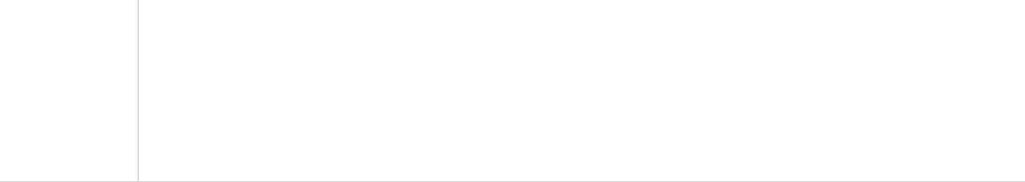

Video/Image | slow-loading.jpeg
Build | https://demo.prestashop.com/#/en/front
Devices
Devices | Windows 11 / Google Chrome

bug report:

ID | Summary
BR-002 | Cart total is incorrect when two discounted products are added

# | Steps to reproduce

- Open the PrestaShop demo

2. | Select a discounted product
3. | Add it to the cart
4. | Select another discounted product
5. | Add it to the cart
6. | Open the Cart or click Proceed to Checkout

- Manually calculate the sum of the displayed product prices and Compare it with the displayed cart total

 | Results
Actual
Actual | The displayed cart total can be at least 0.01 higher than the actual sum of the discounted product prices
Expected
Expected | The cart total should exactly equal the sum of the displayed product prices and applicable charges
 | Additional information

Video/Image | sum-discounted.jpeg
Build | https://demo.prestashop.com/#/en/front
Devices
Devices | Windows 11 / Google Chrome

bug report:

ID | Summary
BR-003 | Registered customer cannot sign in with valid credentials

# | Steps to reproduce

- Open the PrestaShop demo

2. | Click Create your account
3. | Create a new customer account using a valid email address and password
4. | Confirm that the account creation succeeds
5. | Log out of the customer account
6. | Click Sign in

- Enter the same email address and password used during registration
Click Sign in

 | Results
Actual
Actual | The login attempt is rejected and the message “Authentication failed.” is displayed even though the same credentials were used to create the customer account
Expected
Expected | The customer should be authenticated successfully and redirected to their account page when valid registered credentials are entered
 | Additional information

Video/Image | sign-in-again.jpeg
Build | https://demo.prestashop.com/#/en/front
Devices
Devices | Windows 11 / Google Chrome

